Key Issue 1: Where Is Industry Distributed?
Pages 395-397

***Always keep your key term packet out whenever you take notes from Rubenstein. As the terms come up in the text, think through the significance of the term.
- Regarding the Industrial Revolution: What? Where? When?

- Define cottage industry:

- How did the iron industry benefits from the steam engine?

- How is the distribution of steel and iron industry influenced by coal?

- Why was development in transportation necessary?

- What two forms of transportation grew rapidly?

- How did the Industrial Revolution change textiles?

- How did the Industrial Revolution and factory system contribute to the need for food processing?

- As you read the section, make notes on the resources, advantages, conditions, and issues in each of the sub regions of industrial development discussed. Shade and label each of the regions on the maps. (Use maps on pages 396-397 as guides)

Europe

United Kingdom – | Rhine-Ruhr -
Mid-Rhine – | Po Basin -

Northeastern Spain – | Moscow -
St. Petersburg – | Urals –
Volga - | Kuznetsk -
Donetsk – | Silesia -

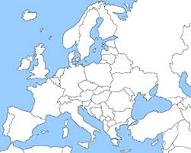

North America

New England – | Middle Atlantic -
Mohawk Valley – | Pittsburgh-Lake Erie -
Western Great Lakes – | Southern California -
Southeastern Ontario –

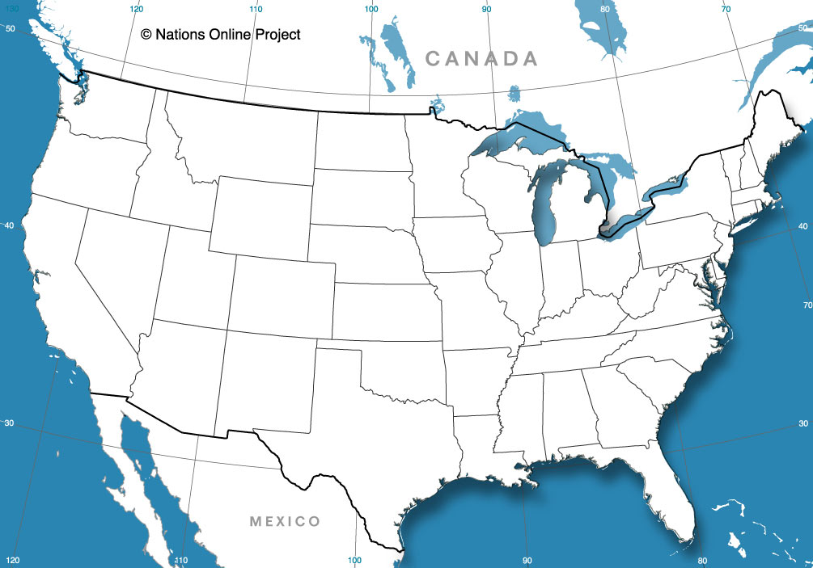

East Asia

Japan – | China -
South Korea –

