Key Issue 2: Where Are People Distributed Within Urban Areas?
Pages 466-475

- Read the following section of this key issue and for each of the three models, annotate the diagrams below and do the following:
- Identify the model by name
- Name the geographer(2) who developed the model
- Define the model
- Identify and label key parts of the model
- Bullet important characteristics and/or features of the model

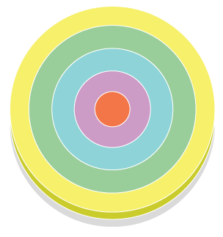

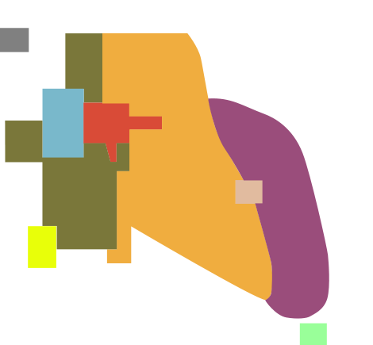

2. What are census tracts?

3. What three types of data are reported by the U.S. Census Bureau regarding the population of each census tract?

4. What is social area analysis?

- What two things can we deduce by combining all three models rather than considering them independently?

- What are the advantages of living in the inner-ring near the city center?

- List three points about the conditions of European suburbs, where the poor live.

- List five ways that a European CBD differs from a North American CBD.

- Explain the Latin American City Model in the chart below as you did for the models above.
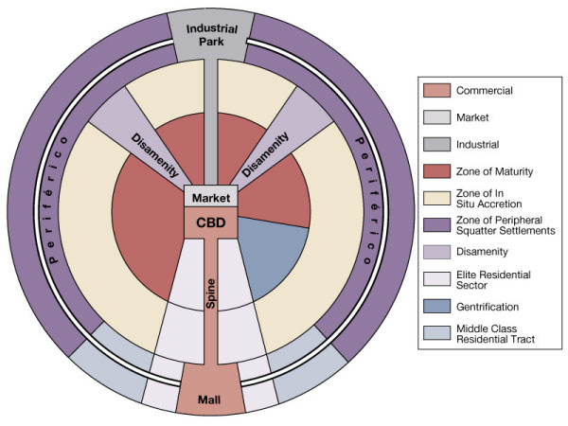
- Describe the elite spine sector developed in Latin American cities.

- What are the causes of squatter settlement?

- Define squatter settlements.

14. Describe services and amenities in a typical squatter settlement.

- Make a simple flowchart which depicts stages in the development of a squatter settlement.

- Cities in Africa, Asia and Latin America resemble European cities in their structure. This is not a coincidence because….

- Draw and label a sketch of a “pre-colonial city”

- Colonial cities often contained a new “European sector” to the side of the pre-colonial city. Contrast their various elements in the table below.

“Old Quarters” – pre-colonial city | “European district” – colonial addition

