Key Issue 2: Why Are Nation-States Difficult to Create?
Pages 268-275
- What is a multiethnic state? Give an example.

- What is a multinational state? Describe in detail how the United Kingdom is an example.

- Why is Denmark a fairly good example of a nation-state?

- Two regions of Denmark prevent the country from being a “perfect” nation-state. List and describe them in the chart below

Denmark’s Non-Danish Regions
Region: | Region:
Description: | Description:

- Shade and label Denmark and her territories on this map of the North Atlantic region.

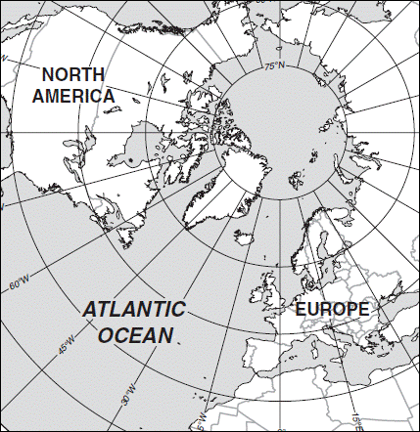
- How did Communists suppress the issues of ethnicity and nationalism? (Give several examples)

- With the fall of Communist governments in the 1990s, what kinds of problems have arisen in what places? Why?

- When the Soviet Union dissolved into 15 countries in the 1990s, the new countries were based on ethnicities. Other than Russia, they can be divided into 4 groups based on their location. Complete the chart below to indicate the countries in each group. NOTE: Be sure to look at the map on pg. 270 to familiarize yourself with the location of these countries.

Baltic Region
(3 states)
Eastern Europe
(3 states)
Central Asia
(5 states)
Caucusus
(3 states)

- Note the major religion and language of each of the Baltic States.

- The ethnic divisions among the Eastern European states are blurred for what reasons?

- What did the majority of Moldovans want when they gained independence? Who opposed this?

- Have there been ethnic problems in Central Asia? If so, where? If not, why not?

- How many different nationalities (ethnicities) are found in the country of Russia?

- Why are independence movements flourishing among these groups?

- Russia has resisted the independence movement in Chechnya for what two reasons?

- In the Caucusus region, there have been many problems with the new nations and ethnicities. Summarize the main problems and note specifics of regions and peoples for each.

Azeris (Azerbaijan)
Armenians (Armenia)
Georgians (Georgia)

- Using Figure 8-22, what’s the main problem with the Caucusus region?

- By definition, what is a colony?

- Define colonialism:

- Summarize three reasons Europeans sought colonies.

- Which country had the largest empire? Second largest?

- Use the chart below to contrast the basic colonial policies of these two countries.

Colonial Practices of… | Colonial Practices of…

- List the largest remaining colonies in the world and who possesses each.

