Issue Overview: Political asylum
By Bloomberg, adapted by Newsela staff
02/01/2017
People in the world are frightened to live in their own countries. They might even be in danger of being harmed by their governments because of the things they believe. So they ask another country to allow them to live there. This is called political asylum.
Political asylum just might be the world’s most controversial universal idea. Most countries offer political asylum. The United Nations (U.N.) declares it as a basic human right.
In the wake of violence, mostly in the Middle East, Afghanistan and parts of Africa, the number of people seeking asylum outside their own countries has risen and is now at a record level.
The disagreement starts when countries try to figure out who should be given political asylum. The idea is that nations protect those who may be harmed, even in other countries. The question is whether support for political asylum can survive today’s flood of refugees and the dislike toward outsiders in some host countries.

The Situation
In his first week in office, U.S. President Donald Trump issued an executive order that would indefinitely ban admission of people fleeing war-torn Syria into the United States. This temporarily freezes the entry of other refugees and prohibits entry by people from seven countries for 90 days. The majority of people in all seven countries are Muslims. Trump was elected after proposing at least a temporary “complete shutdown of Muslims entering the U.S.”
In Europe, nationalist politicians have surged in polls and elections by questioning the acceptance of refugees. Refugees are people who leave their country because of war, a natural disaster or ill treatment because of who they are.
Attacks in Europe and the United States linked to the Islamic State have caused fear. And many think that future terrorists lurk among those seeking asylum in their countries.
In 2015, the number of individuals seeking asylum or to be a refugee rose to 2.45 million. This is an increase of almost 50 percent from the year before. The largest number are from Syria.
For the second time in two years, a Southeast Asian refugee crisis erupted in late 2016. Thousands of Rohingya, a Muslim ethnic group, fled religious persecution in Myanmar in Asia. Tens of thousands of Iraqis have found refuge in France and the United States. The number of asylum claims made by gay, bisexual and transgender people also has increased in recent years.
One country’s refugee can be another country’s wanted man. Think of Edward Snowden. He is the American who was granted asylum by Russia after revealing details of classified U.S. government programs. Another example is Julian Assange. He is the founder of Wikileaks, which is an organization that publishes secret information. Sweden wanted Assange sent back there to face rape claims, but Assange was granted asylum by Ecuador to live in London.
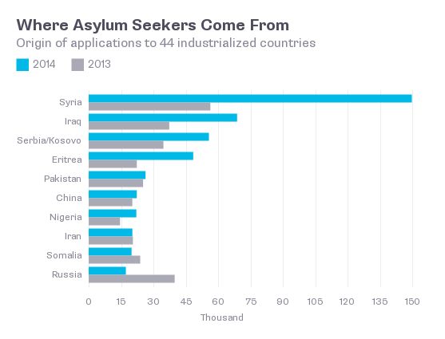

The Background
The Office of the U.N. High Commissioner for Refugees says the idea of asylum is one of the “earliest hallmarks of civilization,” citing references to it in 3,500-year-old texts.
The word comes from the ancient Greek term for "freedom from seizure." The 1951 U.N. Convention relating to refugee distinction and its 1967 Protocol are the modern legal framework for asylum, defining refugees as people who can show they’ll be persecuted at home based on race, religion, birth country, political conviction or social group.
In 2014, 626,500 asylum applications were accepted and 434,900 rejected. Asylum has been used as a political tool, such as when Americans welcomed Cubans and Vietnamese seeking refuge from Communism. Individuals have used it to avoid or delay criminal prosecution. Examples include Snowden, Assange and Charles Taylor, the former Liberian president indicted for war crimes who was given temporary refuge by Nigeria. 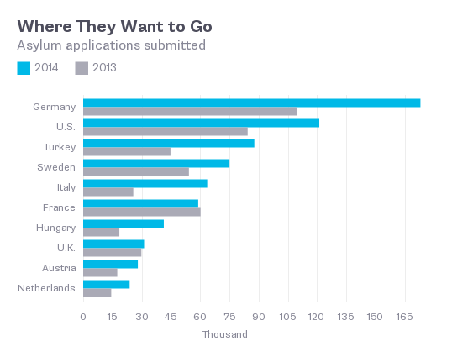

The Argument
More people fleeing violence means a more polarized debate over asylum. Critics say asylum policy has grown too lax and threatens to overthrow the regular immigration process.
Trump argues that the United States has insufficiently screened refugees to keep out potential terrorists. Defenders of the screening policy say it is thorough, but no system is perfect.
Asylum advocates emphasize the universal obligation to protect those who need help. They point out that many of the people Trump would keep out are fleeing the terrorism of the Islamic State.
Some say asylum should be extended to people fleeing danger, not just those exposed to political persecution. They point to the unaccompanied children from Central America who streamed across the U.S.-Mexico border in record numbers in 2014, running from gangs and some of the world’s highest murder rates.
Critics of the U.S. asylum judgments say they are inconsistent. And there is an underground business of sorts that has grown to provide would-be asylum seekers with compelling personal narratives that are exaggerated or false, but would help them get into another country.

